Edwardsville to St. Louis Arch
For the final hike we will be starting in Edwardsville and hiking 20.4 miles to the St. Louis Arch. There will be a 16.8 mile hike, then a short drive followed by the final hike 3.6 miles across the McKinley Bridge down the Mississippi river to the to St. Louis Arch. This hike is on bicycle/hiking trail that are made out of Concrete, with little to no elevation change.
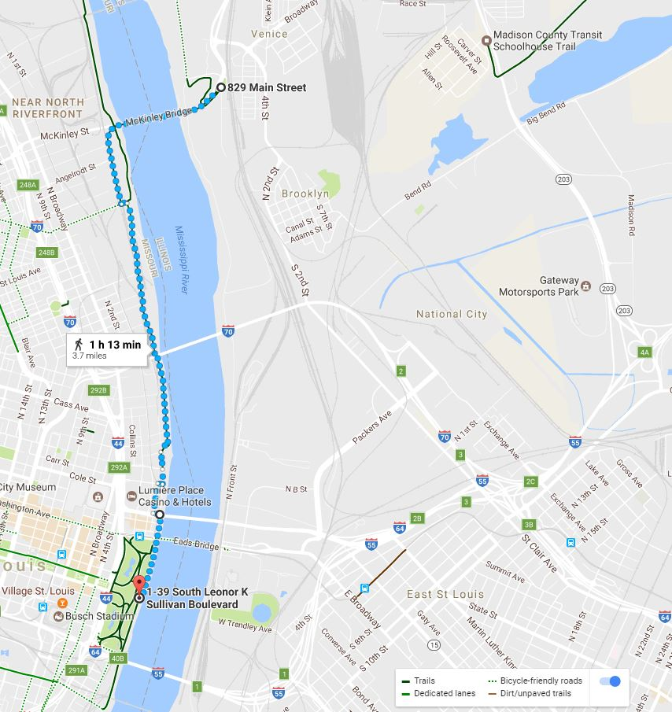
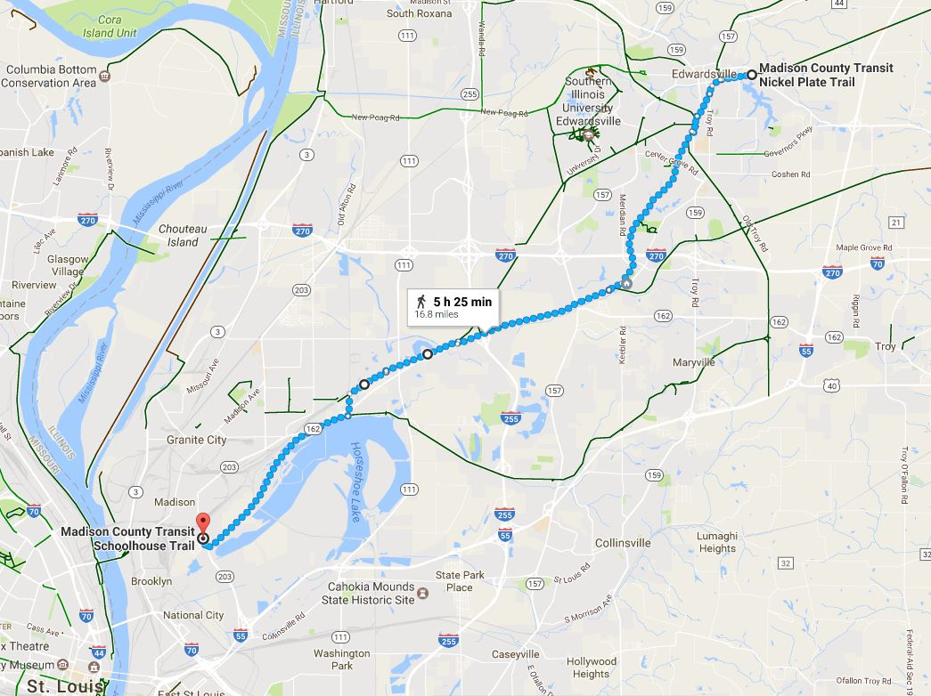

We will start in the parking lot at the intersection of HWY 143 & Schwarz Rd (across the street from the Madison County Highway Department; 7037 Marine Rd, Edwardsville, IL 62025)
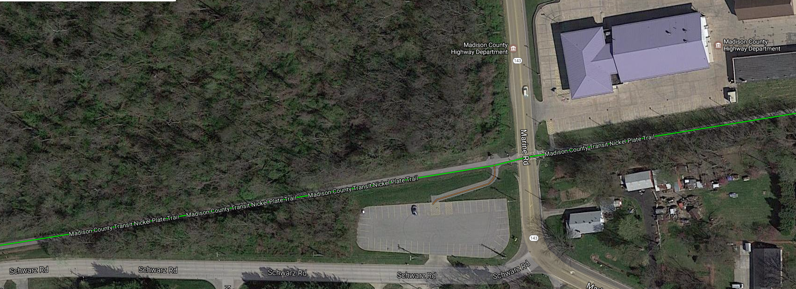
The first leg (16.8 miles) of this route will start on the Nickel Plate trail going 9.3 miles southwest to the Nature Trail, for 3.1 miles will follow the Nature Trail to the Schoolhouse Trail for 4.4 miles ending at the head of the Madison County Transit Schoolhouse Trail (intersection of Harrison St & Hare St, Madison, IL 62060)
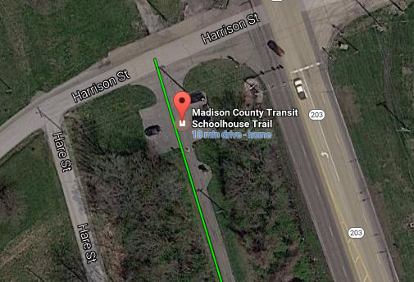
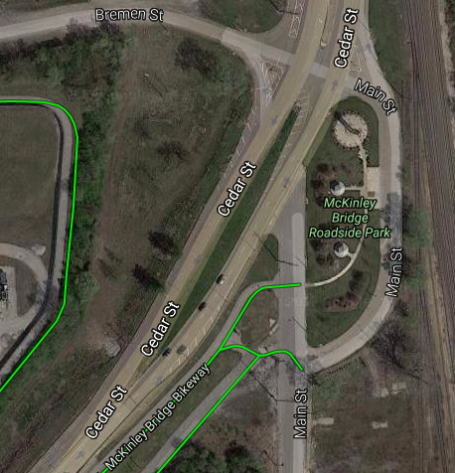
From
Madison County Transit Schoolhouse Trail
Drive to
McKinley Bridge Roadside Park

After a short rest and a drive from the Schoolhouse Trail to the McKinley Bridge Roadside Park we will hike across the McKinley Bridge, and head south on the STL Riverfront Trail for 3.6 miles to the St. Louis Arch ending our trip on the top of the steps under the Arch.

