Troop 216
2022 Piasa Bird/Cahokia Mounds Klondike Derby
January 7-9, 2022

PLACE: | Camp Warren Levis, 5500 Boy Scout Lane, Godfrey, IL 62035
DEPART: | Friday, January 7 – 5:30 pm from First Christian Church Edwardsville parking lot. Please arrive 5:00-5:15pm to check-in and load gear.
RETURN: | Sunday, January 9 – First Christian Church Edwardsville parking lot; no Scout should leave until dismissed by Senior Patrol Leader or Adult Leader.
FOOD: | Eat dinner on own before departure. Troop provides Friday night snack, Saturday meals, Sunday breakfast.
COST: | $28/scout or adult (includes food & general camping costs)
WEAR: | Class A for transportation to and from is mandatory! Class B for activities and weather appropriate clothing for camping. Mask required.  NOTE: Scouts must wear boots or hiking shoes – no tennis shoes allowed. See the next page for a packing list.
CONTACTS: | Mark Mason (302) 256-8597 Albert Middeke (314) 809-3267

PLEASE return permission slip & payment to Ms Bishopp or Mrs Gill
by 7:30 PM on Monday, December 13, 2021

---------------------------------------Submit bottom portion with payment --------------------------------------

I, ____________________________ (parent’s name) give permission for my son, ___________________________ (full name) to attend and participate in all activities that are planned. I also give permission to any medical institution, person, or Scout Leader to render emergency treatment in the event of a medical emergency. My son is in good health and (circle one) is / is not taking any medications. In the event medications are needed, I will give them to the Leader in the original container with written instructions.
Please note pertinent medical information: ______________________________________________________________________________

EMERGENCY CONTACT NAME | PHONE # | RELATIONSHIP

SIGNATURE: _________________________________

☐ Scout – camping or ☐ Scout – Saturday only // ☐ Own tent ☐ Troop tent needed
☐ Adult – camping or ☐ Adult – Saturday only // ☐ Own tent ☐ Troop tent needed
Indicate plan here ↓ if alternate arrival/departure
☐ I allow my Scout to be driven by __________________________________
☐ Please transfer from my Scout’s account to cover this activity

FOR ACTIVITIES CHAIR:  Rec’d on ____________  By DG MB | January 7-9, 2022 Klondike Derby – Camp Warren Levis - $28  Amount Cash Check # Scout Account Notes

Scout Packing List
- Insulated winter boots or hiking boots are required. No sneakers/tennis shoes allowed.
- Weather appropriate clothing:
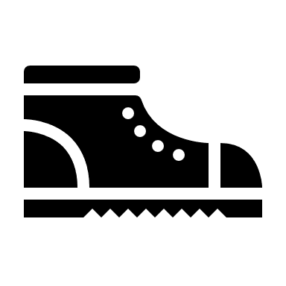
  - Long underwear or other warm layers covering entire body
  - Sweater or fleece
  - Winter coat
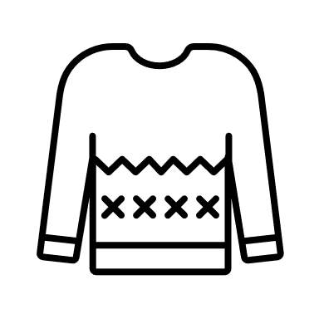
  - Winter hat
  - Scarf
  - Gloves or mittens
  - Raingear
- Plastic bread bags (2) (to put in boots if they leak)
- Extra socks (preferably wool)
- Extra gloves or mittens
- Masks
- Personal first aid kit
- Personal cup or water bottle

